|  |  |
| --- | --- |
|  | **Linear Algebra**  **BSCS- 5th-A**  **Department of Computer Science**  **Bahria University, Lahore Campus** |

**Quiz: [1]** Date: Week 5, 28 March 2024

Name: _____________________ Roll No: ___________________

|  |  |  |  |
| --- | --- | --- | --- |
| **Evaluation of CLO** | **Question Number** | **Marks** | **Obtained Marks** |
| **CLO1: Interpret** the fundamental concepts of linear algebra, vector equations and linear transformations. | 1,2,3,4 | (2+2+3+3) |  |
|  |  |  |
| **Total Marks** | | **10** |  |

**Question 1:**

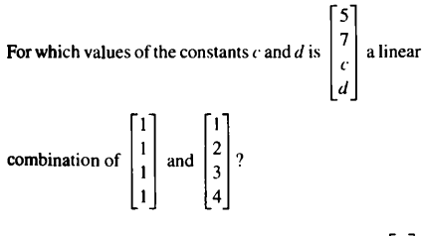

**Solution:**

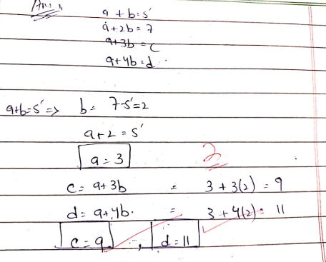

**Question 2:**

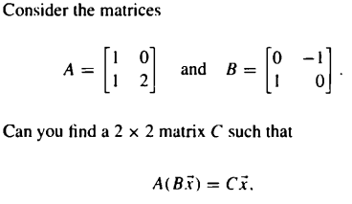

**Solution:**

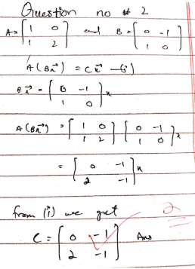

**Question 3:**

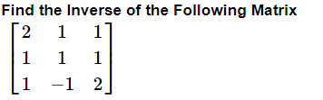

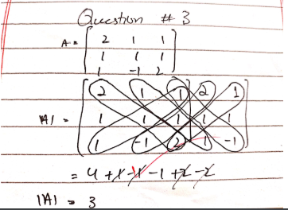 **or** 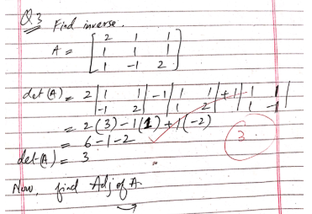

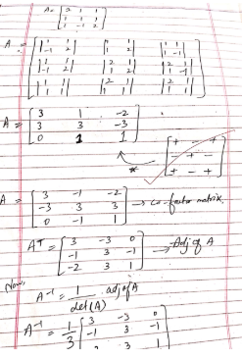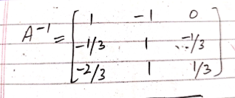

**Question 4:** 